Monitoring Task

Step1:

Install Prometheus & Grafana in the EC2 Machine

Screenshot mentioned Below

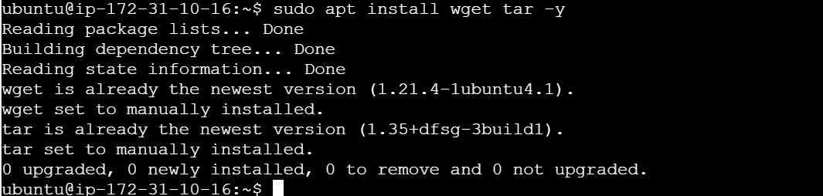

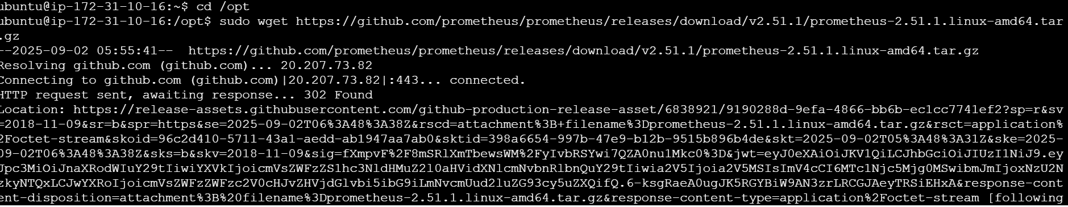

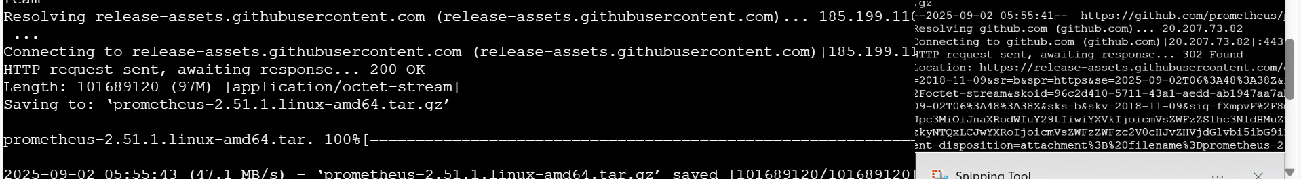

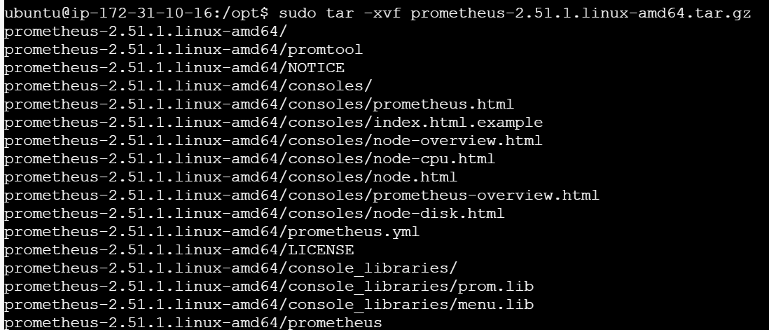

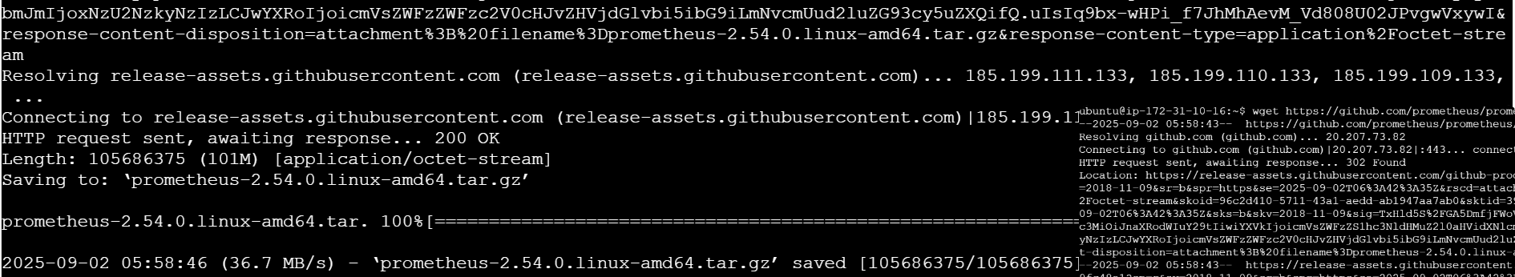

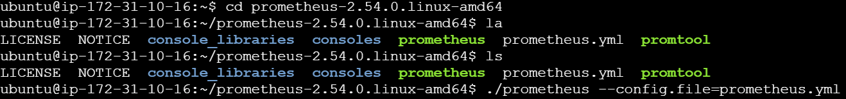

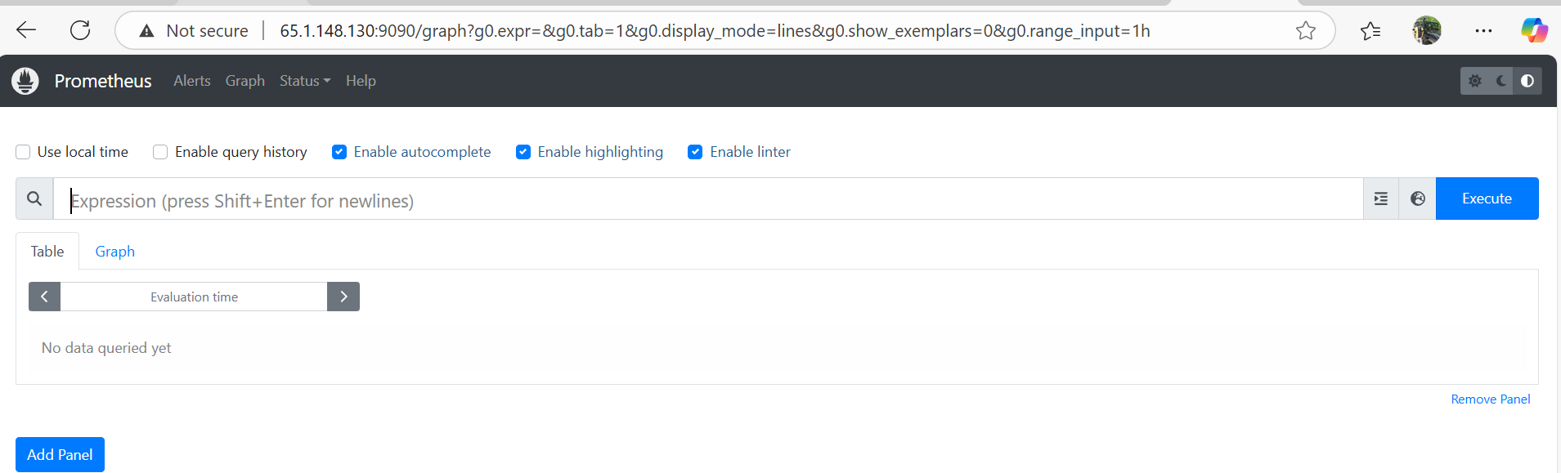

Installing Grafana:

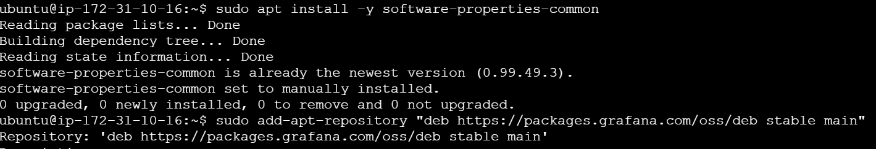

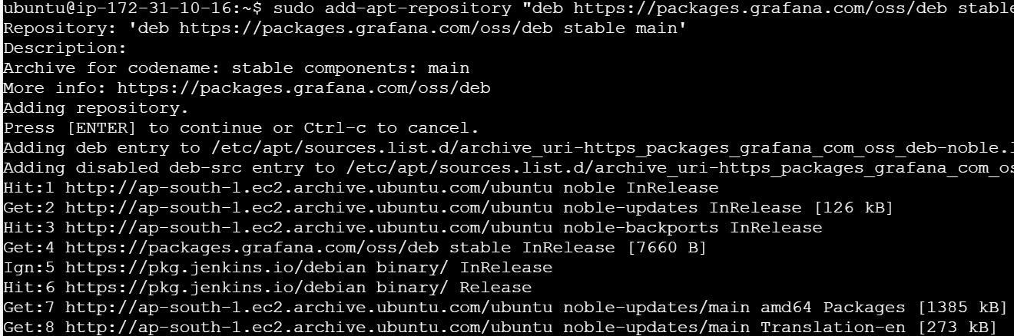



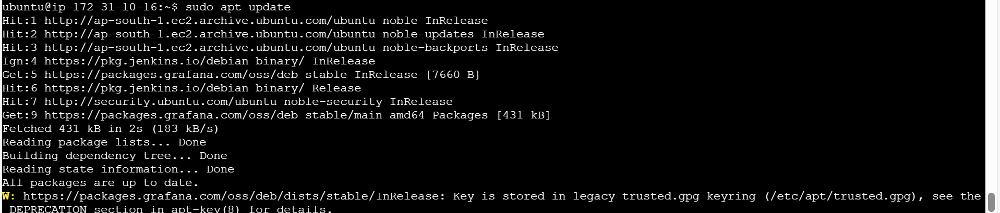

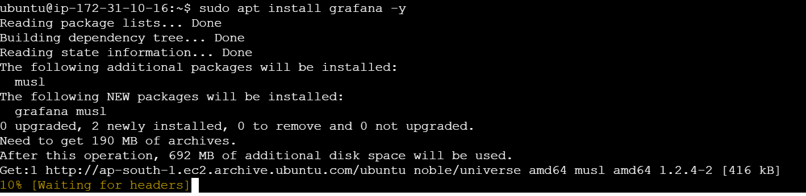



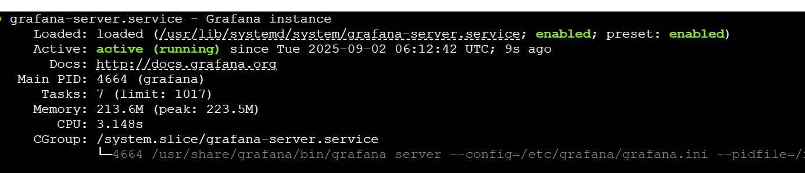

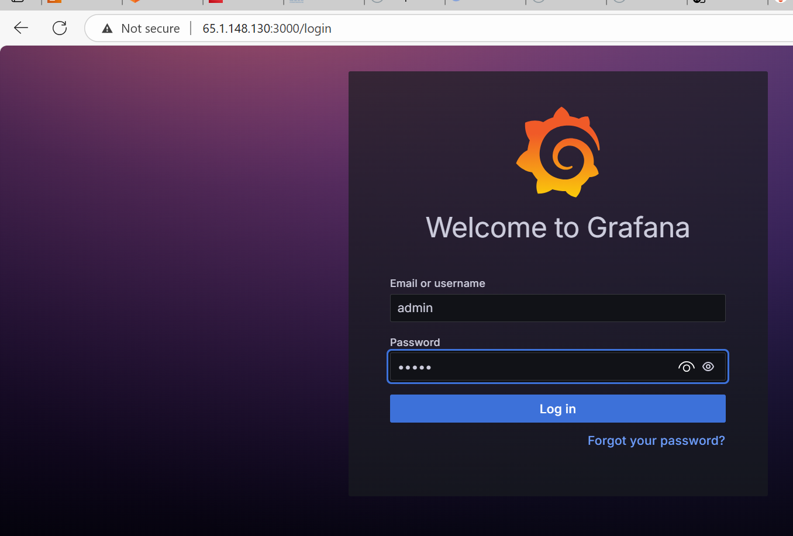

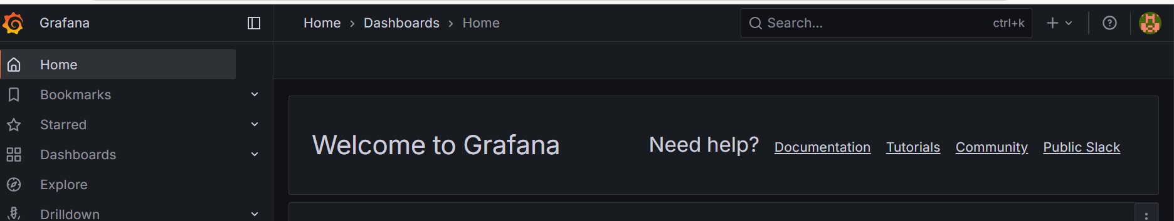

Add the Data Sorce into the Grafana ie. Premetheus

